Module 3 Critical Thinking 2

Alex Zelmanowicz

Colorado State University Global

Professor Farr

CSC 500

2 March 2024

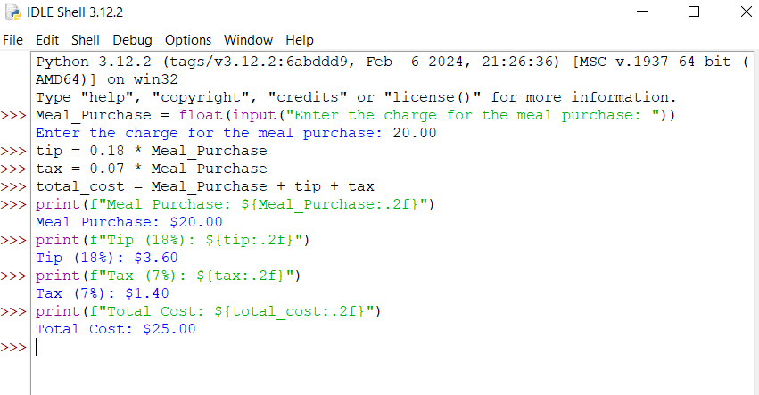

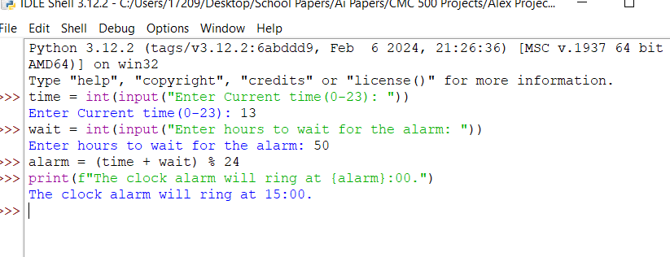

**Part 1 Pseudo Code:**

1. Start

2. Enter the charge for the meal purchase and then store it as a Meal_Purchase variable.

3. Calculate the tip amount to be 18%

4. Calculate the tax amount to be 7%

5. Calculate the total cost of the meal purchase, tax and tip.

6. Display the amount the meal will cost.

7. Display the amount the meal will cost.

8. Display the amount the tip will cost.

9. Display the amount the tax will cost.

10. Display the amount the total will cost.

11. End.

**Part 2 Pseudo Code:**

1. Start.

2. Enter current time in military time (0-23)  
3. Input current time (example 11).

4. Enter the amount of hours needed to wait for the alarm (example 50).

5. Calculate the alarm time (11:00 + 50 hours on a 24 hour clock).

6. Display alarm time.

7. End

**Part 1 Source Code:**

Meal_Purchase = float(input("Enter the charge for the meal purchase: "))

Enter the charge for the meal purchase: 20.00

tip = 0.18 * Meal_Purchase

tax = 0.07 * Meal_Purchase

total_cost = Meal_Purchase + tip + tax

print(f"Meal Purchase: ${Meal_Purchase:.2f}")

Meal Purchase: $20.00

print(f"Tip (18%): ${tip:.2f}")

Tip (18%): $3.60

print(f"Tax (7%): ${tax:.2f}")

Tax (7%): $1.40

print(f"Total Cost: ${total_cost:.2f}")

Total Cost: $25.00

**Part 2 Source Code:**

time = int(input("Enter Current time(0-23): "))

Enter Current time(0-23): 13

wait = int(input("Enter hours to wait for the alarm: "))

Enter hours to wait for the alarm: 50

alarm = (time + wait) % 24

print(f"The clock alarm will ring at {alarm}:00.")

The clock alarm will ring at 15:00.

**Git Repository**: https://github.com/AlexCSUGlobal/CSC500